SR UNIVERSITY

AI ASSISTED CODING
NAME:MANADI SWATHI
HT.NO:2503A51L19
Batch-19

Lab 8: Test-Driven Development with AI – Generating and Working with Test Cases

Lab Objectives:

- To introduce students to test-driven development (TDD) using AI code generation tools.
- To enable the generation of test cases before writing code implementations.
- To reinforce the importance of testing, validation, and error handling.
- To encourage writing clean and reliable code based on AI-generated test expectations.

Lab Outcomes (LOs):
After completing this lab, students will be able to:

- Use AI tools to write test cases for Python functions and classes.
- Implement functions based on test cases in a test-first development style.
- Use unittest or pytest to validate code correctness.
- Analyze the completeness and coverage of AI-generated tests.
- Compare AI-generated and manually written test cases for quality and logic

Task Description#1
Use AI to generate test cases for a function is_prime(n) and then implement the function.
Requirements:
• Only integers > 1 can be prime.
•Check edge cases: 0, 1, 2, negative numbers, and large primes
CODE:
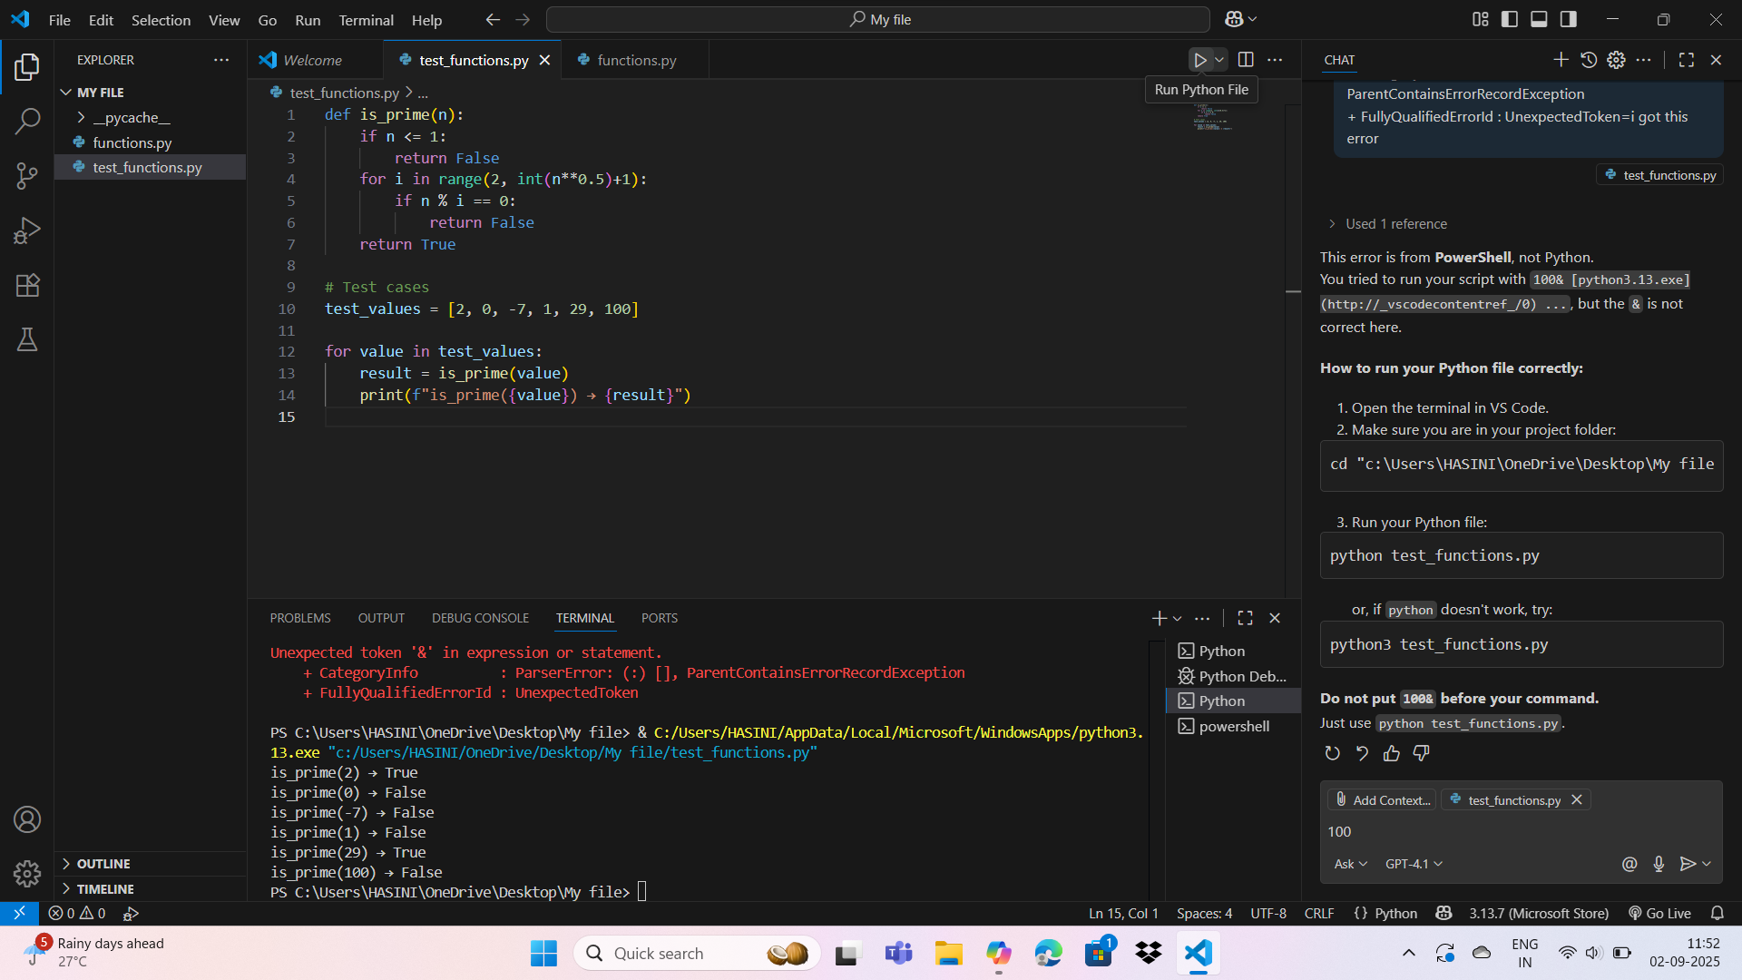
OUTPUT:
Task2#Description(Loops)
• Ask AI to generate test cases for celsius_to_fahrenheit(c) and fahrenheit_to_celsius(f)
Requirements
• Validate known pairs: 0°C = 32°F, 100°C = 212°F.
• Include decimals and invalid inputs like strings or none.
CODE:
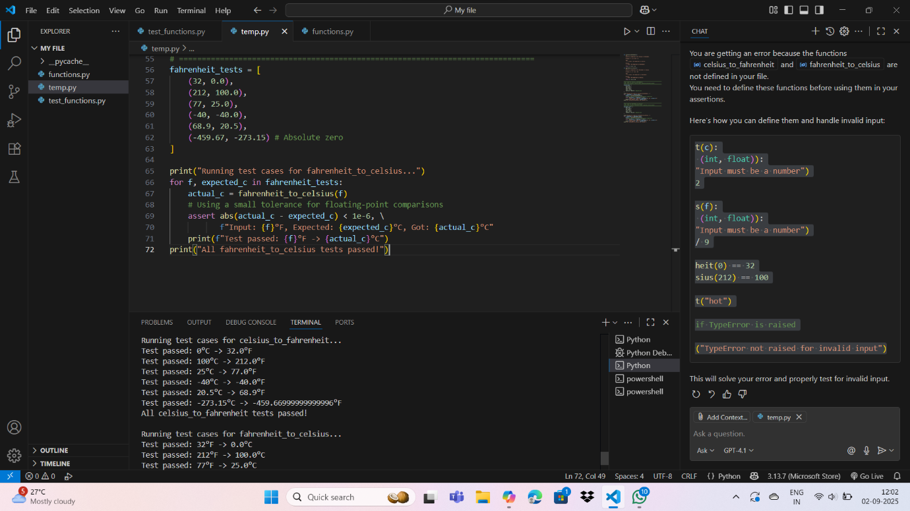
OUTPUT:
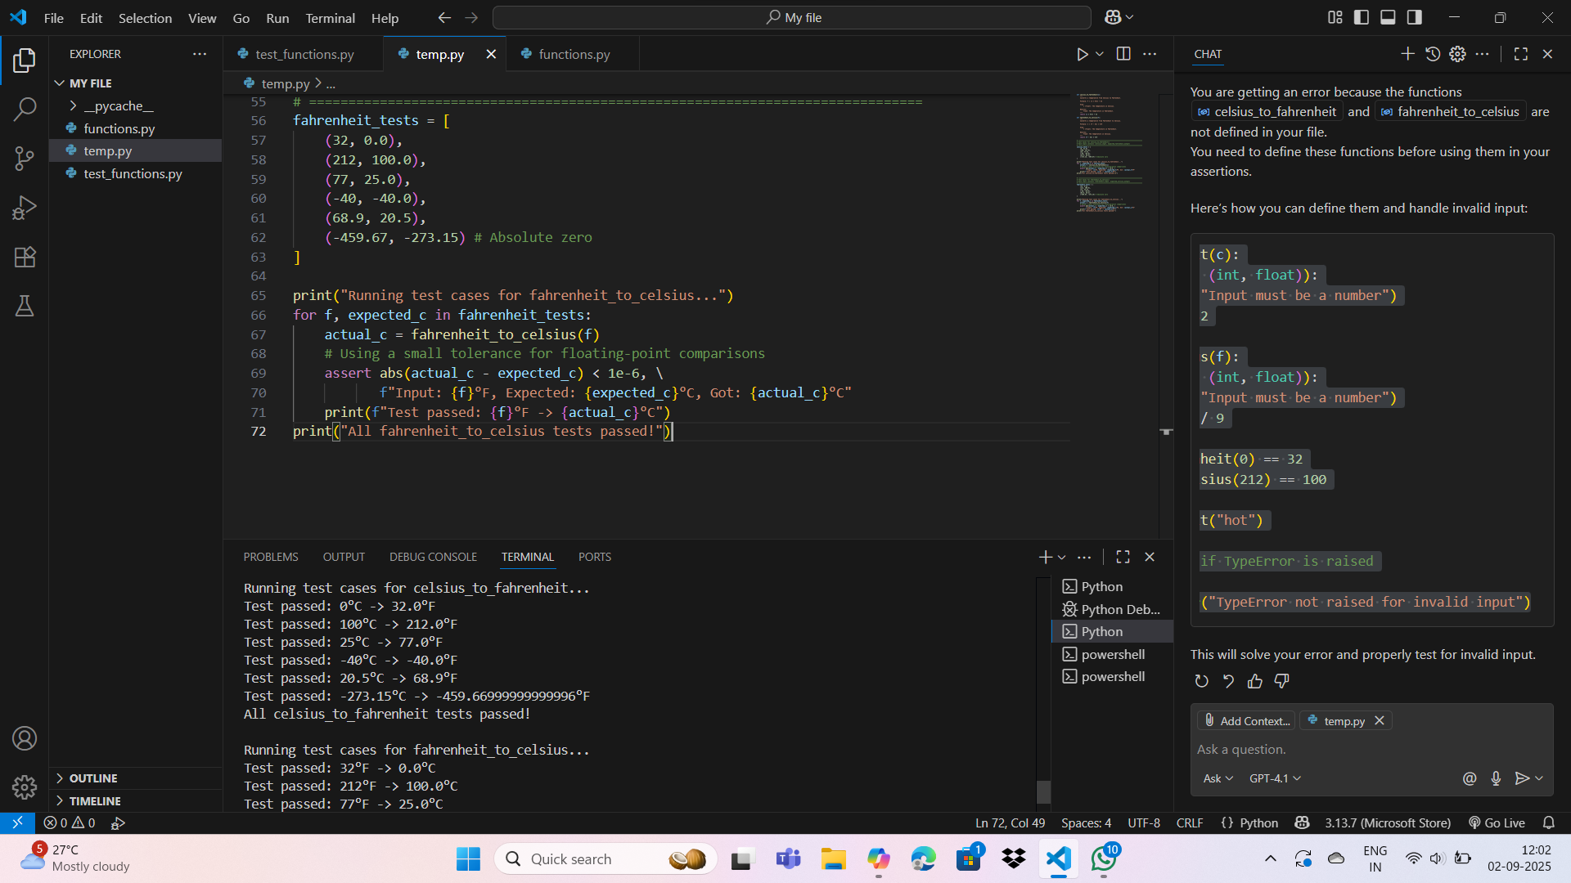
TaskDescription#3
Use AI to write test cases for a function count_words(text) that returns the number of words in a sentence.
Requirement
Handle normal text, multiple spaces, punctuation, and empty and srings.
CODE:
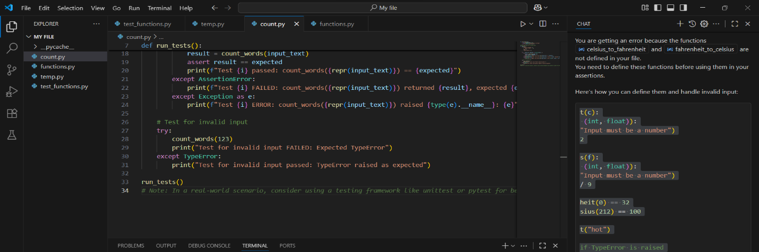
OUTPUT:
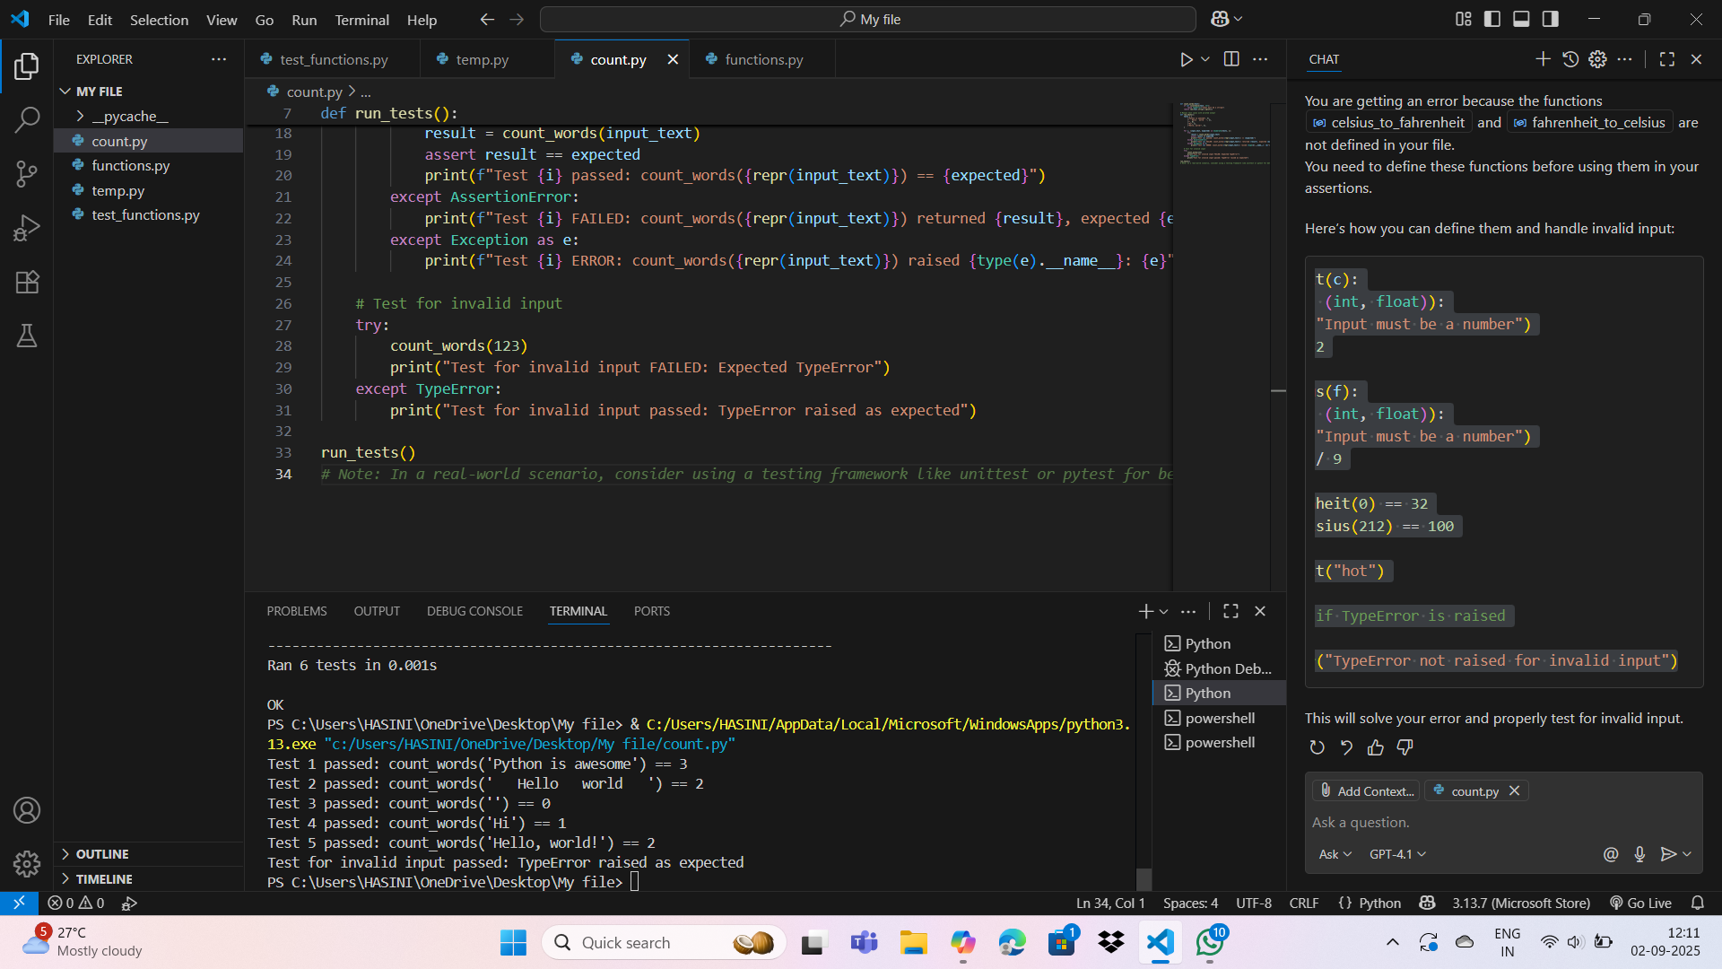
Task Description#4
• Generate test cases for a BankAccount class with:
Methods:
deposit(amount)
withdraw(amount)
check_balance()
Requirements:
• Negative deposits/withdrawals should raise an error.
• Cannot withdraw more than balance.
CODE:
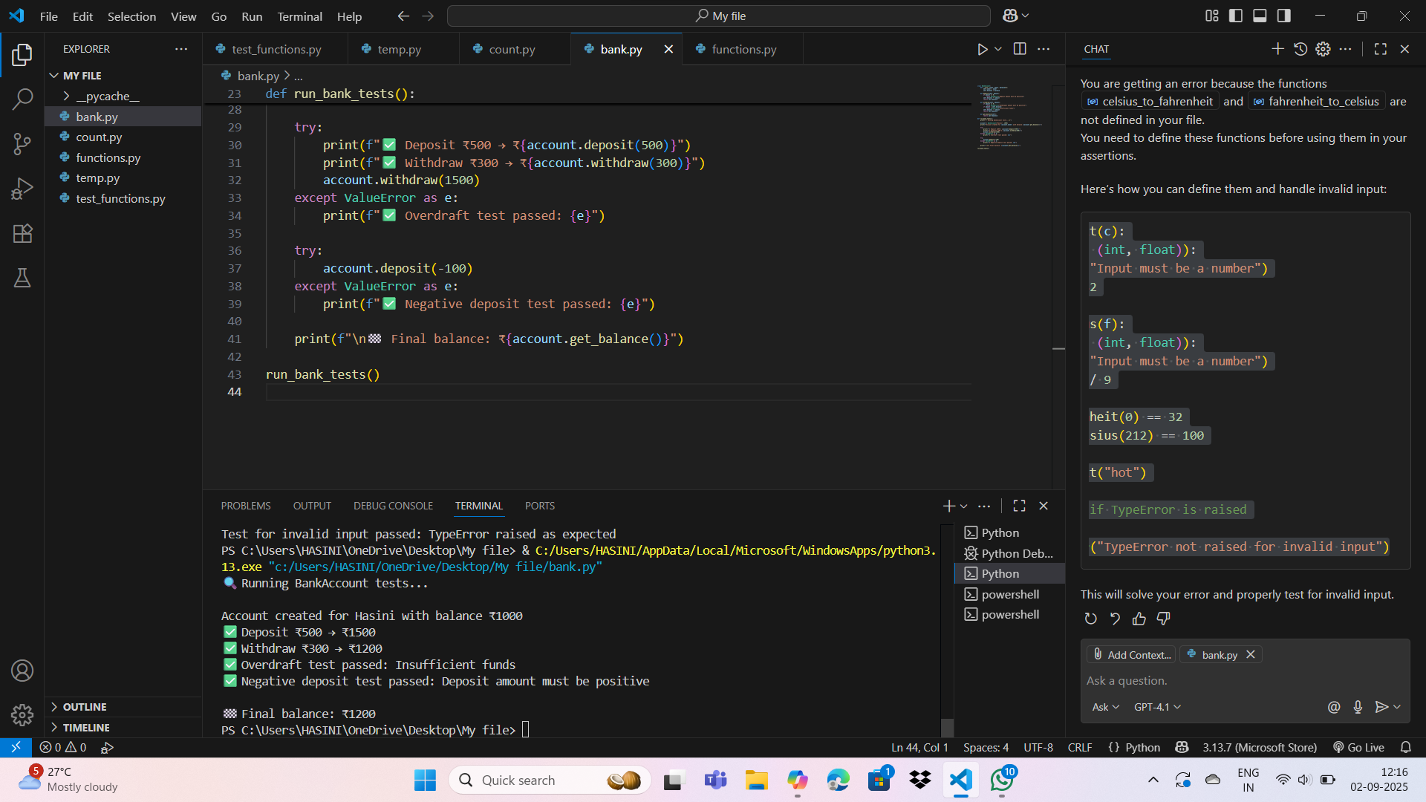
OUTPUT:
Task Description#5
Generate test cases for is_number_palindrome(num), which checks if an integer reads
the same backward.
Examples:
121 → True
123 → False
0, negative numbers → handled gracefully.
CODE:
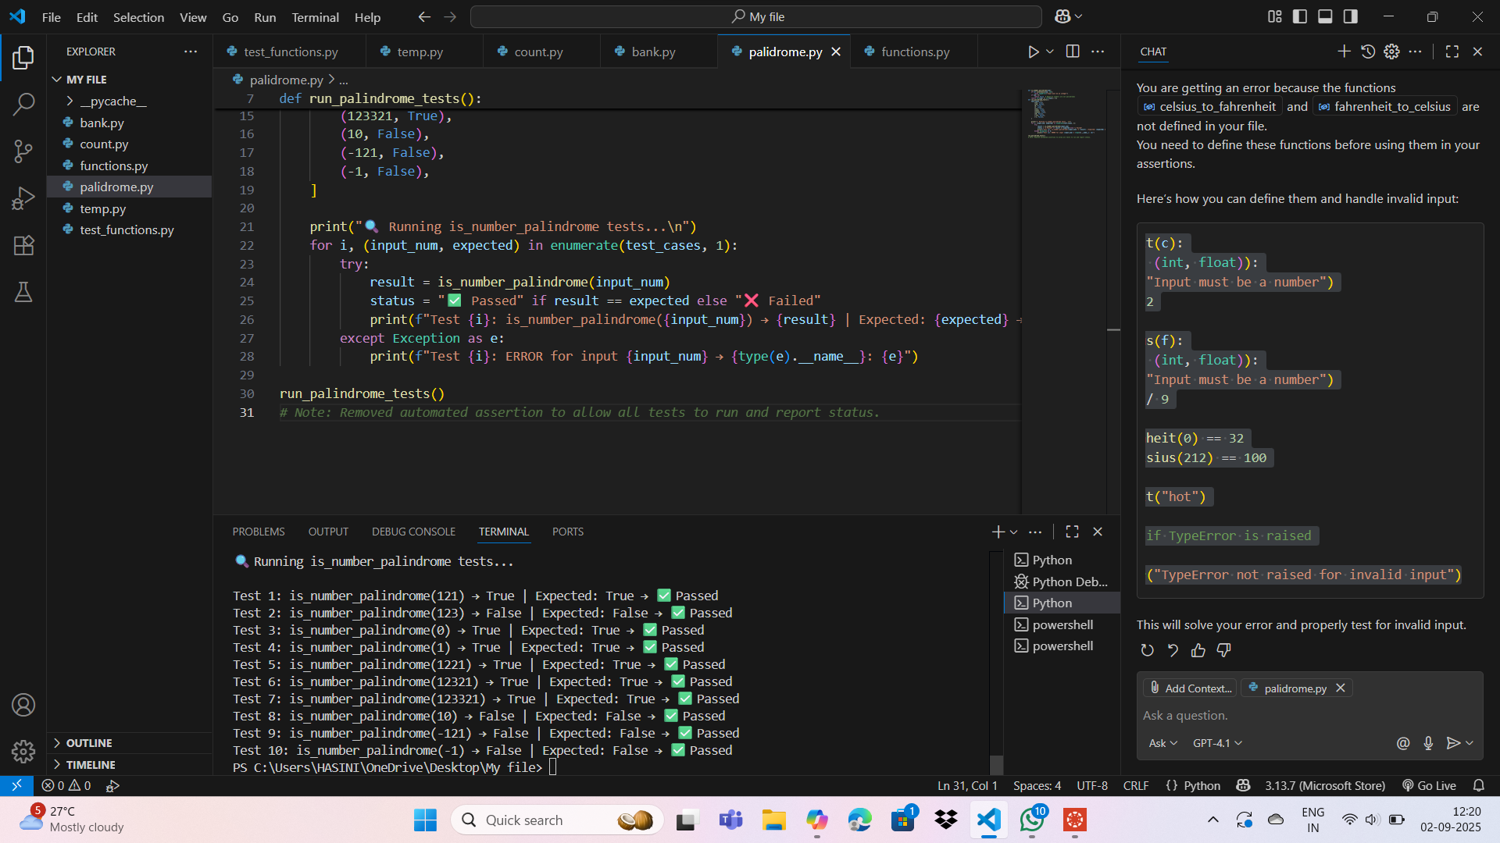
OUTPUT:

OBSERVATIONS:
By completing this assignment, I am able to:
• Use AI tools to write test cases for Python functions and classes.
• Implement functions based on test cases in a test-first development style.
• Use unittest or pytest to validate code correctness.
• Analyze the completeness and coverage of AI-generated tests.
• Compare AI-generated and manually written test cases for quality and logic.

